C964 Computer Science Capstone
  - Part D: Other Documentation

Visualizations
Visualization 1: RAG Data Composition
This pie chart shows the composition of the RAG knowledge base. The classic schema documents outnumber AVM modules by more than 40-to-1, which proved that a simple search would fail. This discovery made the deterministic search.ismatch() filter a critical design requirement.
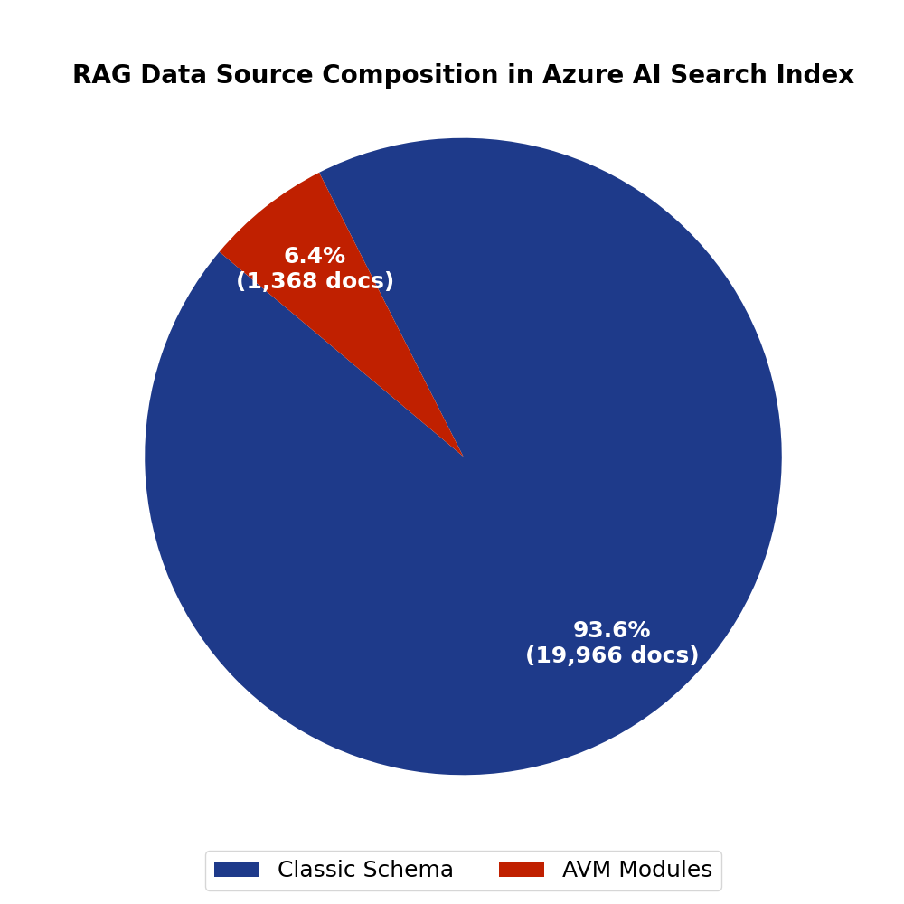
Visualization 2: System Architecture Diagram
This diagram shows the project's secure, event-driven RAG architecture. It illustrates how the user's request flows from the Container App to the correct, filtered data in AI Search, which is then used by the AI Model to generate the code, all within a secure VNet using Private Endpoints.
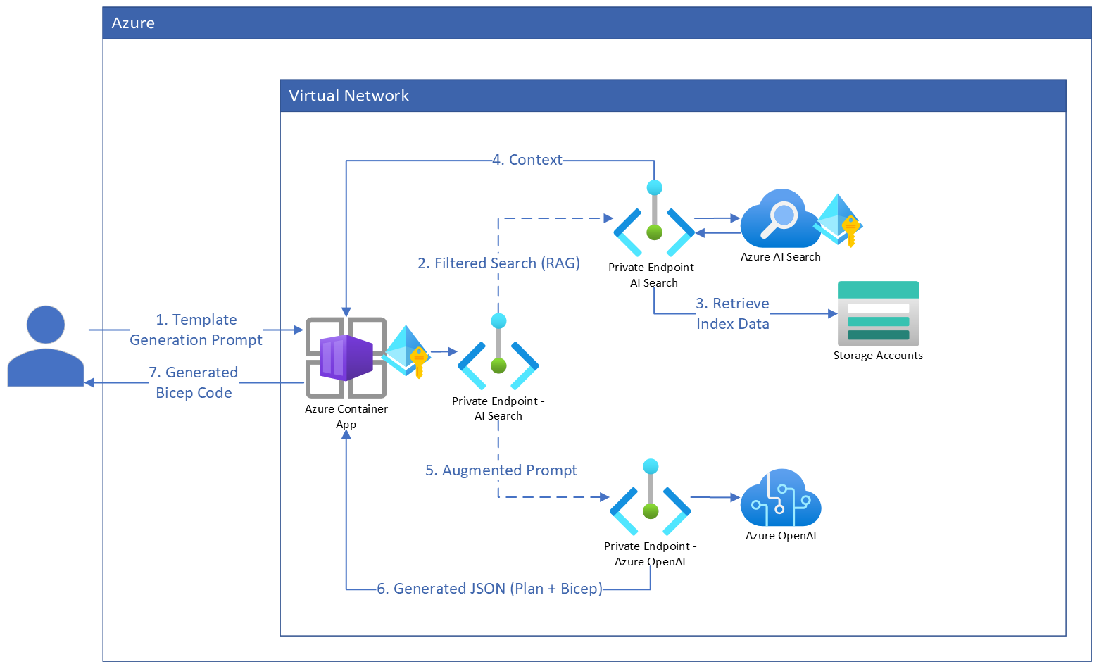
Visualization 3: Token Accuracy Graph
This graph of the token accuracy from the model's fine-tuning job shows a rapid climb to over 90% accuracy. This metric proves the model successfully learned the complex, strict JSON schema required for the agentic architecture, which was critical for ensuring reliable, parsable output.
